MPI
Number of Threads | Distance from Pi | Time
1 | 0.00848 | 8.6136
2 | 0.00848 | 4.30402
4 | 0.00849 | 2.39975
8 | 0.00309 | 2.2477
16 | 0.00230 | 2.07996
32 | 0.00210 | 2.36175
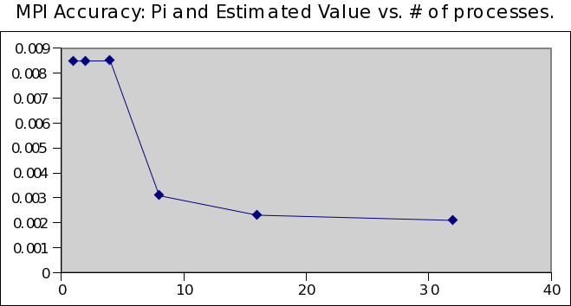
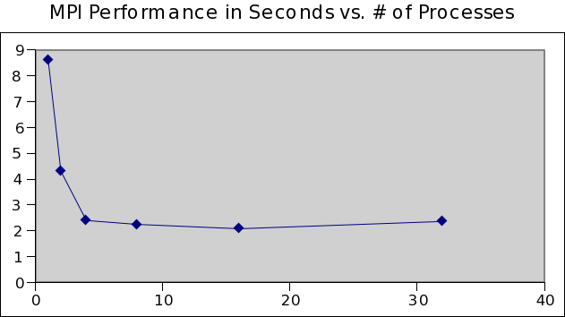

OpenMP
Number of Threads | Distance from Math.h | Time
1 | 0.00848 | 8.72854
2 | 0.00848 | 4.33068
4 | 0.00849 | 2.18457
8 | 0.00309 | 2.12846
16 | 0.00230 | 1.86204
32 | 0.00210 | 1.71238
